Question 1



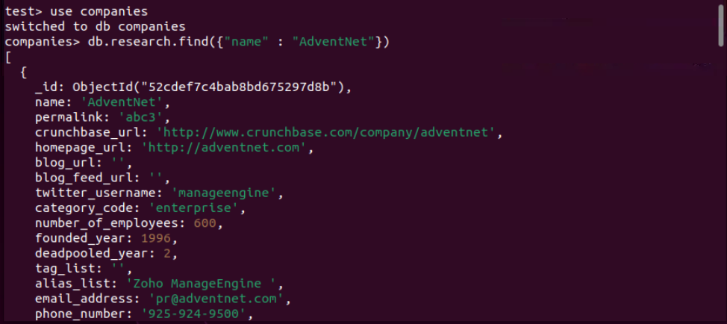



Question 2

db.research.find({founded_year: {$gt: 2010}}).sort({name: 1}).limit(20)

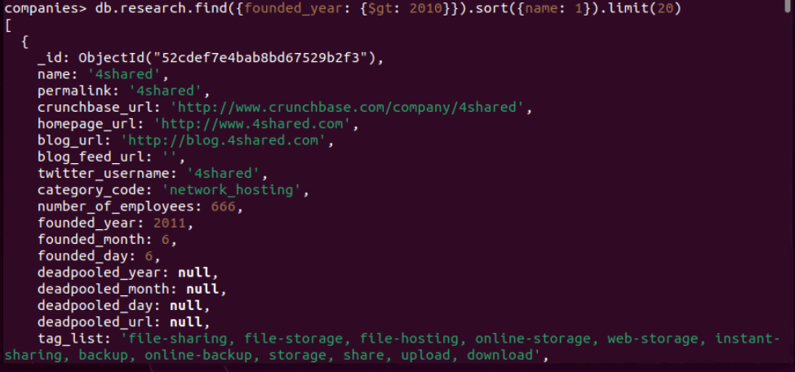

db.research.find({"offices.state_code": {"$in": ["CA", "TX"]}}, {"name": 1, "number_of_employees": 1, "_id": 0}).sort({"number_of_employees": -1}).limit(20)

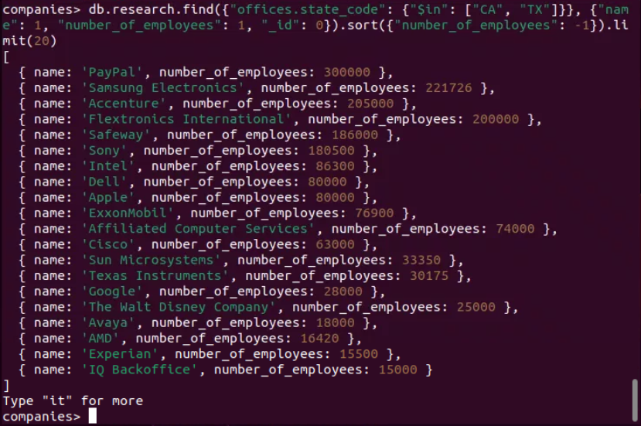

Question 3

db.research.aggregate([

{$unwind: "$offices"},

{$match: {"offices.country_code": "USA"}},

{$group: {_id: "$offices.state_code", totalOffices: {$sum: 1}}}

])

Explanation

1. Unwind the offices array, which will create a separate document for each office in each company.
2. Match documents where the offices.country_code field is equal to "USA".
3. Group the documents by the offices.state_code field and calculate the total number of offices in each state.

